1. Use the given link and locate the bank marketing dataset. Data Set Link Perform the below operations: a. Create a visual for representing missing values in the dataset. b. Show a distribution of clients based on a Job. c. Check whether is there any relation between Job and Marital Status? d. Check whether is there any association between Job and Education?

## The data set can be obtained from http://archive.ics.uci.edu/ml/datasets/Bank+Marketing ## DATASET UNDERSTANDING library(readr) bank_full <- read_delim("C:/Users/Seshan/Desktop/Bank/bank-full.csv", ";", escape_double = FALSE, trim_ws = TRUE) ## Parsed with column specification: ## cols( ## age = col_integer(), ## job = col_character(), ## marital = col_character(), ## education = col_character(), ## default = col_character(), ## balance = col_integer(), ## housing = col_character(), ## loan = col_character(), ## contact = col_character(), ## day = col_integer(), ## month = col_character(), ## duration = col_integer(), ## campaign = col_integer(), ## pdays = col_integer(), ## previous = col_integer(), ## poutcome = col_character(), ## y = col_character() ## )

#Lets look at dataset and generate initial understanding about the column types str(bank_full) ## Classes 'tbl_df', 'tbl' and 'data.frame': 45211 obs. of 17 variables: ## $ age : int 58 44 33 47 33 35 28 42 58 43 ... ## $ job : chr "management" "technician" "entrepreneur" "blue-collar" ... ## $ marital : chr "married" "single" "married" "married" ... ## $ education: chr "tertiary" "secondary" "secondary" "unknown" ... ## $ default : chr "no" "no" "no" "no" ... ## $ balance : int 2143 29 2 1506 1 231 447 2 121 593 ... ## $ housing : chr "yes" "yes" "yes" "yes" ... ## $ loan : chr "no" "no" "yes" "no" ... ## $ contact : chr "unknown" "unknown" "unknown" "unknown" ... ## $ day : int 5 5 5 5 5 5 5 5 5 5 ... ## $ month : chr "may" "may" "may" "may" ... ## $ duration : int 261 151 76 92 198 139 217 380 50 55 ... ## $ campaign : int 1 1 1 1 1 1 1 1 1 1 ... ## $ pdays : int -1 -1 -1 -1 -1 -1 -1 -1 -1 -1 ... ## $ previous : int 0 0 0 0 0 0 0 0 0 0 ... ## $ poutcome : chr "unknown" "unknown" "unknown" "unknown" ... ## $ y : chr "no" "no" "no" "no" ... ## - attr(*, "spec")=List of 2 ## ..$ cols :List of 17 ## .. ..$ age : list() ## .. .. ..- attr(*, "class")= chr "collector_integer" "collector" ## .. ..$ job : list() ## .. .. ..- attr(*, "class")= chr "collector_character" "collector" ## .. ..$ marital : list() ## .. .. ..- attr(*, "class")= chr "collector_character" "collector" ## .. ..$ education: list() ## .. .. ..- attr(*, "class")= chr "collector_character" "collector" ## .. ..$ default : list() ## .. .. ..- attr(*, "class")= chr "collector_character" "collector" ## .. ..$ balance : list() ## .. .. ..- attr(*, "class")= chr "collector_integer" "collector" ## .. ..$ housing : list() ## .. .. ..- attr(*, "class")= chr "collector_character" "collector" ## .. ..$ loan : list() ## .. .. ..- attr(*, "class")= chr "collector_character" "collector" ## .. ..$ contact : list() ## .. .. ..- attr(*, "class")= chr "collector_character" "collector" ## .. ..$ day : list() ## .. .. ..- attr(*, "class")= chr "collector_integer" "collector" ## .. ..$ month : list() ## .. .. ..- attr(*, "class")= chr "collector_character" "collector" ## .. ..$ duration : list() ## .. .. ..- attr(*, "class")= chr "collector_integer" "collector" ## .. ..$ campaign : list()

## .. .. ..- attr(*, "class")= chr "collector_integer" "collector" ## .. ..$ pdays : list() ## .. .. ..- attr(*, "class")= chr "collector_integer" "collector" ## .. ..$ previous : list() ## .. .. ..- attr(*, "class")= chr "collector_integer" "collector" ## .. ..$ poutcome : list() ## .. .. ..- attr(*, "class")= chr "collector_character" "collector" ## .. ..$ y : list() ## .. .. ..- attr(*, "class")= chr "collector_character" "collector" ## ..$ default: list() ## .. ..- attr(*, "class")= chr "collector_guess" "collector" ## ..- attr(*, "class")= chr "col_spec"

a. Create a visual for representing missing values in the dataset.

#A deep check for NA in a particular column let say age if(length(which(is.na(bank_full$age)==TRUE)>0)){ print("Missing Value found in the specified column") } else print("All okay: No Missing Value found in the specified column") ## [1] "All okay: No Missing Value found in the specified column" # Check another example say if(length(which(is.na(bank_full$campaign)==TRUE)>0)){print("Missing Value found in the specified column")} else print("All okay: No Missing Value found in the specified column") ## [1] "All okay: No Missing Value found in the specified column" head(bank_full) ## Displays first 6 rows for each variable ## # A tibble: 6 x 17 ## age job marital education default balance housing loan contact ## <int> <chr> <chr> <chr> <chr> <int> <chr> <chr> <chr> ## 1 58 management married tertiary no 2143 yes no unknown ## 2 44 technician single secondary no 29 yes no unknown ## 3 33 entrepren~ married secondary no 2 yes yes unknown ## 4 47 blue-coll~ married unknown no 1506 yes no unknown ## 5 33 unknown single unknown no 1 no no unknown ## 6 35 management married tertiary no 231 yes no unknown ## # ... with 8 more variables: day <int>, month <chr>, duration <int>, ## # campaign <int>, pdays <int>, previous <int>, poutcome <chr>, y <chr> str(bank_full) ## Describes each variables

## Classes 'tbl_df', 'tbl' and 'data.frame': 45211 obs. of 17 variables: ## $ age : int 58 44 33 47 33 35 28 42 58 43 ... ## $ job : chr "management" "technician" "entrepreneur" "blue-collar" ... ## $ marital : chr "married" "single" "married" "married" ... ## $ education: chr "tertiary" "secondary" "secondary" "unknown" ... ## $ default : chr "no" "no" "no" "no" ... ## $ balance : int 2143 29 2 1506 1 231 447 2 121 593 ... ## $ housing : chr "yes" "yes" "yes" "yes" ... ## $ loan : chr "no" "no" "yes" "no" ... ## $ contact : chr "unknown" "unknown" "unknown" "unknown" ... ## $ day : int 5 5 5 5 5 5 5 5 5 5 ... ## $ month : chr "may" "may" "may" "may" ... ## $ duration : int 261 151 76 92 198 139 217 380 50 55 ... ## $ campaign : int 1 1 1 1 1 1 1 1 1 1 ... ## $ pdays : int -1 -1 -1 -1 -1 -1 -1 -1 -1 -1 ... ## $ previous : int 0 0 0 0 0 0 0 0 0 0 ... ## $ poutcome : chr "unknown" "unknown" "unknown" "unknown" ... ## $ y : chr "no" "no" "no" "no" ... ## - attr(*, "spec")=List of 2 ## ..$ cols :List of 17 ## .. ..$ age : list() ## .. .. ..- attr(*, "class")= chr "collector_integer" "collector" ## .. ..$ job : list() ## .. .. ..- attr(*, "class")= chr "collector_character" "collector" ## .. ..$ marital : list() ## .. .. ..- attr(*, "class")= chr "collector_character" "collector" ## .. ..$ education: list() ## .. .. ..- attr(*, "class")= chr "collector_character" "collector" ## .. ..$ default : list() ## .. .. ..- attr(*, "class")= chr "collector_character" "collector" ## .. ..$ balance : list() ## .. .. ..- attr(*, "class")= chr "collector_integer" "collector" ## .. ..$ housing : list() ## .. .. ..- attr(*, "class")= chr "collector_character" "collector" ## .. ..$ loan : list() ## .. .. ..- attr(*, "class")= chr "collector_character" "collector" ## .. ..$ contact : list() ## .. .. ..- attr(*, "class")= chr "collector_character" "collector" ## .. ..$ day : list() ## .. .. ..- attr(*, "class")= chr "collector_integer" "collector" ## .. ..$ month : list() ## .. .. ..- attr(*, "class")= chr "collector_character" "collector" ## .. ..$ duration : list() ## .. .. ..- attr(*, "class")= chr "collector_integer" "collector" ## .. ..$ campaign : list() ## .. .. ..- attr(*, "class")= chr "collector_integer" "collector" ## .. ..$ pdays : list() ## .. .. ..- attr(*, "class")= chr "collector_integer" "collector" ## .. ..$ previous : list()

## .. .. ..- attr(*, "class")= chr "collector_integer" "collector" ## .. ..$ poutcome : list() ## .. .. ..- attr(*, "class")= chr "collector_character" "collector" ## .. ..$ y : list() ## .. .. ..- attr(*, "class")= chr "collector_character" "collector" ## ..$ default: list() ## .. ..- attr(*, "class")= chr "collector_guess" "collector" ## ..- attr(*, "class")= chr "col_spec" summary(bank_full) ## Provides basic statistical information of each variable ## age job marital education ## Min. :18.00 Length:45211 Length:45211 Length:45211 ## 1st Qu.:33.00 Class :character Class :character Class :character ## Median :39.00 Mode :character Mode :character Mode :character ## Mean :40.94 ## 3rd Qu.:48.00 ## Max. :95.00 ## default balance housing loan ## Length:45211 Min. : -8019 Length:45211 Length:45211 ## Class :character 1st Qu.: 72 Class :character Class :character ## Mode :character Median : 448 Mode :character Mode :character ## Mean : 1362 ## 3rd Qu.: 1428 ## Max. :102127 ## contact day month duration ## Length:45211 Min. : 1.00 Length:45211 Min. : 0.0 ## Class :character 1st Qu.: 8.00 Class :character 1st Qu.: 103.0 ## Mode :character Median :16.00 Mode :character Median : 180.0 ## Mean :15.81 Mean : 258.2 ## 3rd Qu.:21.00 3rd Qu.: 319.0 ## Max. :31.00 Max. :4918.0 ## campaign pdays previous poutcome ## Min. : 1.000 Min. : -1.0 Min. : 0.0000 Length:45211 ## 1st Qu.: 1.000 1st Qu.: -1.0 1st Qu.: 0.0000 Class :character ## Median : 2.000 Median : -1.0 Median : 0.0000 Mode :character ## Mean : 2.764 Mean : 40.2 Mean : 0.5803 ## 3rd Qu.: 3.000 3rd Qu.: -1.0 3rd Qu.: 0.0000 ## Max. :63.000 Max. :871.0 Max. :275.0000 ## y ## Length:45211 ## Class :character ## Mode :character ## ## ## ## DATA EXPLORATION - Check for Missing Data ## Option 1 is.na(bank_full) ## Displays True for a missing value

## age job marital education default balance housing loan ## [1,] FALSE FALSE FALSE FALSE FALSE FALSE FALSE FALSE ## [2,] FALSE FALSE FALSE FALSE FALSE FALSE FALSE FALSE ## [3,] FALSE FALSE FALSE FALSE FALSE FALSE FALSE FALSE ## [4,] FALSE FALSE FALSE FALSE FALSE FALSE FALSE FALSE ## [5,] FALSE FALSE FALSE FALSE FALSE FALSE FALSE FALSE ## [6,] FALSE FALSE FALSE FALSE FALSE FALSE FALSE FALSE ## [7,] FALSE FALSE FALSE FALSE FALSE FALSE FALSE FALSE ## [8,] FALSE FALSE FALSE FALSE FALSE FALSE FALSE FALSE ## [9,] FALSE FALSE FALSE FALSE FALSE FALSE FALSE FALSE ## [10,] FALSE FALSE FALSE FALSE FALSE FALSE FALSE FALSE ## [11,] FALSE FALSE FALSE FALSE FALSE FALSE FALSE FALSE ## [12,] FALSE FALSE FALSE FALSE FALSE FALSE FALSE FALSE ## [13,] FALSE FALSE FALSE FALSE FALSE FALSE FALSE FALSE ## [14,] FALSE FALSE FALSE FALSE FALSE FALSE FALSE FALSE ## [15,] FALSE FALSE FALSE FALSE FALSE FALSE FALSE FALSE ## [16,] FALSE FALSE FALSE FALSE FALSE FALSE FALSE FALSE ## [17,] FALSE FALSE FALSE FALSE FALSE FALSE FALSE FALSE ## [18,] FALSE FALSE FALSE FALSE FALSE FALSE FALSE FALSE ## [19,] FALSE FALSE FALSE FALSE FALSE FALSE FALSE FALSE ## [20,] FALSE FALSE FALSE FALSE FALSE FALSE FALSE FALSE ## [21,] FALSE FALSE FALSE FALSE FALSE FALSE FALSE FALSE ## [22,] FALSE FALSE FALSE FALSE FALSE FALSE FALSE FALSE ## [23,] FALSE FALSE FALSE FALSE FALSE FALSE FALSE FALSE ## [24,] FALSE FALSE FALSE FALSE FALSE FALSE FALSE FALSE ## [25,] FALSE FALSE FALSE FALSE FALSE FALSE FALSE FALSE ## [26,] FALSE FALSE FALSE FALSE FALSE FALSE FALSE FALSE ## [27,] FALSE FALSE FALSE FALSE FALSE FALSE FALSE FALSE ## [28,] FALSE FALSE FALSE FALSE FALSE FALSE FALSE FALSE ## [29,] FALSE FALSE FALSE FALSE FALSE FALSE FALSE FALSE ## [30,] FALSE FALSE FALSE FALSE FALSE FALSE FALSE FALSE ## [31,] FALSE FALSE FALSE FALSE FALSE FALSE FALSE FALSE ## [32,] FALSE FALSE FALSE FALSE FALSE FALSE FALSE FALSE ## [33,] FALSE FALSE FALSE FALSE FALSE FALSE FALSE FALSE ## [34,] FALSE FALSE FALSE FALSE FALSE FALSE FALSE FALSE ## [35,] FALSE FALSE FALSE FALSE FALSE FALSE FALSE FALSE ## [36,] FALSE FALSE FALSE FALSE FALSE FALSE FALSE FALSE ## [37,] FALSE FALSE FALSE FALSE FALSE FALSE FALSE FALSE ## [38,] FALSE FALSE FALSE FALSE FALSE FALSE FALSE FALSE ## [39,] FALSE FALSE FALSE FALSE FALSE FALSE FALSE FALSE ## [40,] FALSE FALSE FALSE FALSE FALSE FALSE FALSE FALSE ## [41,] FALSE FALSE FALSE FALSE FALSE FALSE FALSE FALSE ## [42,] FALSE FALSE FALSE FALSE FALSE FALSE FALSE FALSE ## [43,] FALSE FALSE FALSE FALSE FALSE FALSE FALSE FALSE ## [44,] FALSE FALSE FALSE FALSE FALSE FALSE FALSE FALSE ## [45,] FALSE FALSE FALSE FALSE FALSE FALSE FALSE FALSE ## [46,] FALSE FALSE FALSE FALSE FALSE FALSE FALSE FALSE ## [47,] FALSE FALSE FALSE FALSE FALSE FALSE FALSE FALSE ## [48,] FALSE FALSE FALSE FALSE FALSE FALSE FALSE FALSE ## [49,] FALSE FALSE FALSE FALSE FALSE FALSE FALSE FALSE

Deleted remaining false as it is very lengthy FALSE FALSE FALSE FALSE FALSE ## [4653,] FALSE FALSE FALSE FALSE FALSE FALSE FALSE FALSE ## [4654,] FALSE FALSE FALSE FALSE FALSE FALSE FALSE FALSE ## [4655,] FALSE FALSE FALSE FALSE FALSE FALSE FALSE FALSE ## [4656,] FALSE FALSE FALSE FALSE FALSE FALSE FALSE FALSE ## [4657,] FALSE FALSE FALSE FALSE FALSE FALSE FALSE FALSE ## [4658,] FALSE FALSE FALSE FALSE FALSE FALSE FALSE FALSE ## [4659,] FALSE FALSE FALSE FALSE FALSE FALSE FALSE FALSE ## [4660,] FALSE FALSE FALSE FALSE FALSE FALSE FALSE FALSE ## [4661,] FALSE FALSE FALSE FALSE FALSE FALSE FALSE FALSE ## [4662,] FALSE FALSE FALSE FALSE FALSE FALSE FALSE FALSE ## [4663,] FALSE FALSE FALSE FALSE FALSE FALSE FALSE FALSE ## [4664,] FALSE FALSE FALSE FALSE FALSE FALSE FALSE FALSE ## [4665,] FALSE FALSE FALSE FALSE FALSE FALSE FALSE FALSE ## [4666,] FALSE FALSE FALSE FALSE FALSE FALSE FALSE FALSE ## [4667,] FALSE FALSE FALSE FALSE FALSE FALSE FALSE FALSE ## [4668,] FALSE FALSE FALSE FALSE FALSE FALSE FALSE FALSE ## [4669,] FALSE FALSE FALSE FALSE FALSE FALSE FALSE FALSE ## [4670,] FALSE FALSE FALSE FALSE FALSE FALSE FALSE FALSE ## [4671,] FALSE FALSE FALSE FALSE FALSE FALSE FALSE FALSE ## [4672,] FALSE FALSE FALSE FALSE FALSE FALSE FALSE FALSE ## [4673,] FALSE FALSE FALSE FALSE FALSE FALSE FALSE FALSE ## [4674,] FALSE FALSE FALSE FALSE FALSE FALSE FALSE FALSE ## [4675,] FALSE FALSE FALSE FALSE FALSE FALSE FALSE FALSE ## [4676,] FALSE FALSE FALSE FALSE FALSE FALSE FALSE FALSE ## [4677,] FALSE FALSE FALSE FALSE FALSE FALSE FALSE FALSE ## [4678,] FALSE FALSE FALSE FALSE FALSE FALSE FALSE FALSE ## [4679,] FALSE FALSE FALSE FALSE FALSE FALSE FALSE FALSE ## [4680,] FALSE FALSE FALSE FALSE FALSE FALSE FALSE FALSE ## [4681,] FALSE FALSE FALSE FALSE FALSE FALSE FALSE FALSE ## [4682,] FALSE FALSE FALSE FALSE FALSE FALSE FALSE FALSE ## [4683,] FALSE FALSE FALSE FALSE FALSE FALSE FALSE FALSE ## [4684,] FALSE FALSE FALSE FALSE FALSE FALSE FALSE FALSE ## [4685,] FALSE FALSE FALSE FALSE FALSE FALSE FALSE FALSE ## [4686,] FALSE FALSE FALSE FALSE FALSE FALSE FALSE FALSE ## [4687,] FALSE FALSE FALSE FALSE FALSE FALSE FALSE FALSE ## [4688,] FALSE FALSE FALSE FALSE FALSE FALSE FALSE FALSE ## [4689,] FALSE FALSE FALSE FALSE FALSE FALSE FALSE FALSE ## [4690,] FALSE FALSE FALSE FALSE FALSE FALSE FALSE FALSE ## [4691,] FALSE FALSE FALSE FALSE FALSE FALSE FALSE FALSE ## [4692,] FALSE FALSE FALSE FALSE FALSE FALSE FALSE FALSE ## [4693,] FALSE FALSE FALSE FALSE FALSE FALSE FALSE FALSE ## [4694,] FALSE FALSE FALSE FALSE FALSE FALSE FALSE FALSE ## [4695,] FALSE FALSE FALSE FALSE FALSE FALSE FALSE FALSE ## [4696,] FALSE FALSE FALSE FALSE FALSE FALSE FALSE FALSE ## [4697,] FALSE FALSE FALSE FALSE FALSE FALSE FALSE FALSE ## [4698,] FALSE FALSE FALSE FALSE FALSE FALSE FALSE FALSE ## [4699,] FALSE FALSE FALSE FALSE FALSE FALSE FALSE FALSE

## [5867,] FALSE ## [5868,] FALSE ## [5869,] FALSE ## [5870,] FALSE ## [5871,] FALSE ## [5872,] FALSE ## [5873,] FALSE ## [5874,] FALSE ## [5875,] FALSE ## [5876,] FALSE ## [5877,] FALSE ## [5878,] FALSE ## [5879,] FALSE ## [5880,] FALSE ## [5881,] FALSE ## [5882,] FALSE ## [ reached getOption("max.print") -- omitted 39329 rows ]

## Since it is a large dataset, graphical display of missing values will prove to be easier ##Option 2 require(Amelia) ## Loading required package: Amelia ## Loading required package: Rcpp ## ## ## ## Amelia II: Multiple Imputation ## ## (Version 1.7.5, built: 2018-05-07) ## ## Copyright (C) 2005-2018 James Honaker, Gary King and Matthew Blackwell ## ## Refer to http://gking.harvard.edu/amelia/ for more information ## ##

missmap(bank_full,main="Missing Data - Bank ", col=c("red","grey"),legend=FALSE) ## Warning in if (class(obj) == "amelia") {: the condition has length > 1 and ## only the first element will be used ## Warning: Unknown or uninitialised column: 'arguments'.

## Warning: Unknown or uninitialised column: 'arguments'. ## Warning: Unknown or uninitialised column: 'imputations'.

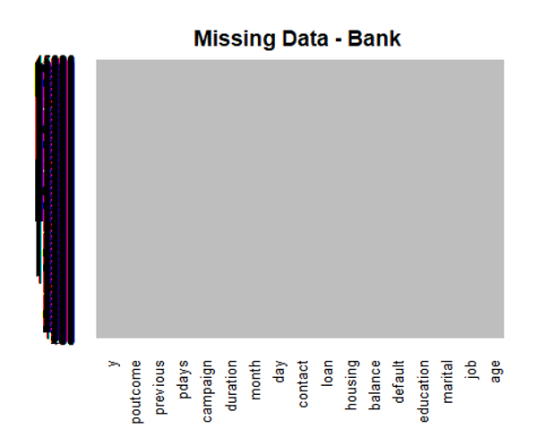

## No red colour stripes are visible. hence no missing values. summary(bank_full) ## displays missing values if any under every variable ## age job marital education ## Min. :18.00 Length:45211 Length:45211 Length:45211 ## 1st Qu.:33.00 Class :character Class :character Class :character ## Median :39.00 Mode :character Mode :character Mode :character ## Mean :40.94 ## 3rd Qu.:48.00 ## Max. :95.00 ## default balance housing loan ## Length:45211 Min. : -8019 Length:45211 Length:45211 ## Class :character 1st Qu.: 72 Class :character Class :character ## Mode :character Median : 448 Mode :character Mode :character ## Mean : 1362 ## 3rd Qu.: 1428 ## Max. :102127 ## contact day month duration ## Length:45211 Min. : 1.00 Length:45211 Min. : 0.0 ## Class :character 1st Qu.: 8.00 Class :character 1st Qu.: 103.0 ## Mode :character Median :16.00 Mode :character Median : 180.0 ## Mean :15.81 Mean : 258.2 ## 3rd Qu.:21.00 3rd Qu.: 319.0 ## Max. :31.00 Max. :4918.0 ## campaign pdays previous poutcome ## Min. : 1.000 Min. : -1.0 Min. : 0.0000 Length:45211 ## 1st Qu.: 1.000 1st Qu.: -1.0 1st Qu.: 0.0000 Class :character

## Median : 2.000 Median : -1.0 Median : 0.0000 Mode :character ## Mean : 2.764 Mean : 40.2 Mean : 0.5803 ## 3rd Qu.: 3.000 3rd Qu.: -1.0 3rd Qu.: 0.0000 ## Max. :63.000 Max. :871.0 Max. :275.0000 ## y ## Length:45211 ## Class :character ## Mode :character ## ## ##

b. Show a distribution of clients based on a Job. c. Check whether is there any relation between Job and Marital Status? d. Check whether is there any association between Job and Education?

b. Show a distribution of clients based on a Job. ## Barplotsfor Categorical Variables barplot(table(bank_full$job),col="red",main="JOB")

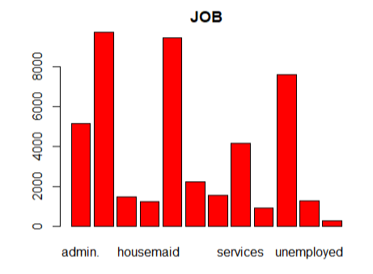 barplot(table(bank_full$marital),col="green",main="Marital")

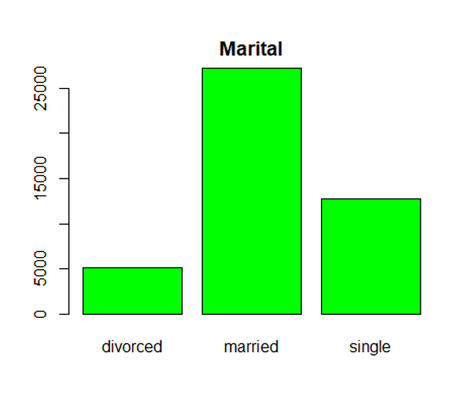 barplot(table(bank_full$education),col="red",main="Education")

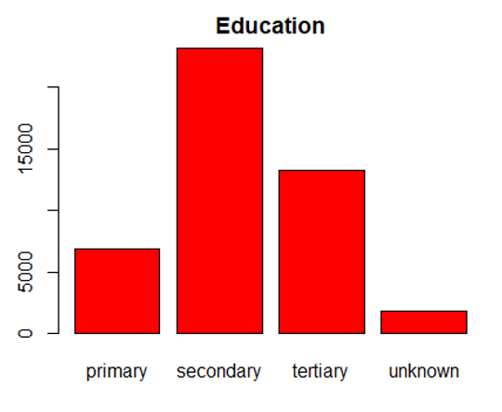

par(oma=c(2,0,0,0)) #so labels are not cut off barplot(table(bank_full$job),ylab = "Frequency", main = "bank_full$job", border="black", col="grey",las=2)

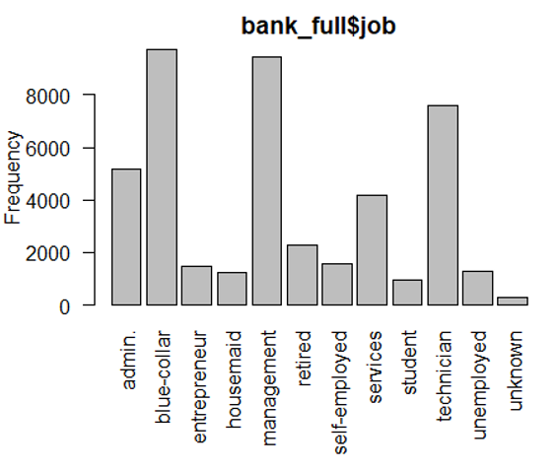

#Histogram for job,marital and education - three categorical variables

par(oma=c(2,0,0,0)) #so labels are not cut off barplot(table(bank_full$job),ylab = "Frequency", main = "bank_full$job", border="yellow", col="violet",las=2)

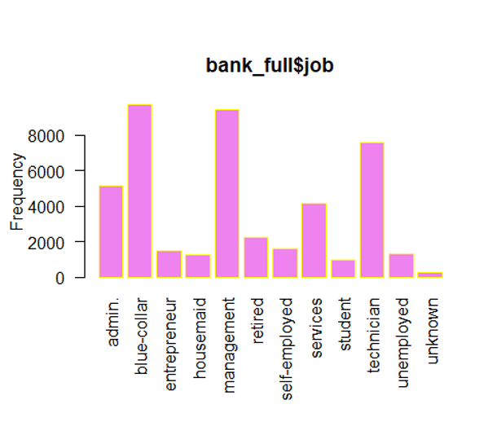

par(oma=c(2,0,0,0)) #so labels are not cut off barplot(table(bank_full$marital),ylab = "Frequency", main = "bank_full$marital", border="green", col="yellow",las=2) 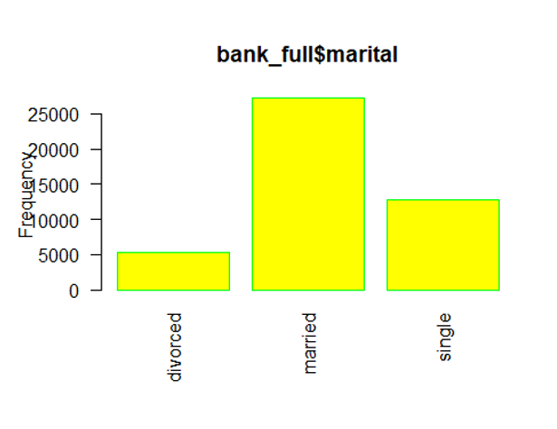 par(oma=c(2,0,0,0)) #so labels are not cut off barplot(table(bank_full$education),ylab = "Frequency", main = "bank_full$education", border="red", col="blue",las=2)

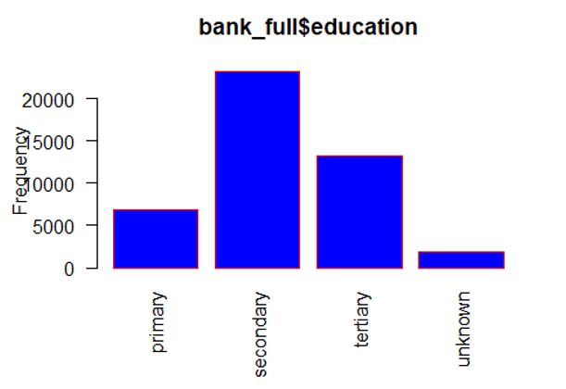

c. Check whether is there any relation between Job and Marital Status?

As both are a categorical variable this can be checked with chisq.test with(bank_full, chisq.test( job, marital)) ## ## Pearson's Chi-squared test ## ## data: job and marital ## X-squared = 3837.6, df = 22, p-value < 2.2e-16 with(bank_full, table( job, marital) ) ## marital ## job divorced married single ## admin. 750 2693 1728 ## blue-collar 750 6968 2014 ## entrepreneur 179 1070 238 ## housemaid 184 912 144 ## management 1111 5400 2947 ## retired 425 1731 108 ## self-employed 140 993 446 ## services 549 2407 1198 ## student 6 54 878

## technician 925 4052 2620 ## unemployed 171 731 401 ## unknown 17 203 68 # OR with(bank_full, prop.table(table( job,education))) ## education ## job primary secondary tertiary unknown ## admin. 0.0046227688 0.0933179978 0.0126517883 0.0037822654 ## blue-collar 0.0831213643 0.1187985225 0.0032956581 0.0100418040 ## entrepreneur 0.0040476875 0.0119882330 0.0151732985 0.0016810068 ## housemaid 0.0138683064 0.0087368118 0.0038265024 0.0009953330 ## management 0.0065028422 0.0247948508 0.1725465042 0.0053526797 ## retired 0.0175842162 0.0217646148 0.0080953750 0.0026321028 ## self-employed 0.0028754064 0.0127623808 0.0184247196 0.0008626219 ## services 0.0076308863 0.0764636925 0.0044679392 0.0033177766 ## student 0.0009732145 0.0112362036 0.0049324279 0.0036053173 ## technician 0.0034947247 0.1156576939 0.0435292296 0.0053526797 ## unemployed 0.0056844573 0.0161022760 0.0063922497 0.0006414368 ## unknown 0.0011280441 0.0015704143 0.0008626219 0.0028090509

#<2.2e-16 means 0.00000000000000022. It is (very much) less than 0.05

d. Check whether is there any association between Job and Education?

As both are a categorical variable this can be checked with chisq.test

with(bank_full, chisq.test( job,education)) ## ## Pearson's Chi-squared test ## ## data: job and education ## X-squared = 28483, df = 33, p-value < 2.2e-16 with(bank_full, table( job, education) ) ## education ## job primary secondary tertiary unknown ## admin. 209 4219 572 171 ## blue-collar 3758 5371 149 454 ## entrepreneur 183 542 686 76 ## housemaid 627 395 173 45 ## management 294 1121 7801 242 ## retired 795 984 366 119

## self-employed 130 577 833 39 ## services 345 3457 202 150 ## student 44 508 223 163 ## technician 158 5229 1968 242 ## unemployed 257 728 289 29 ## unknown 51 71 39 127 # OR with(bank_full, prop.table(table( job,education))) ## education ## job primary secondary tertiary unknown ## admin. 0.0046227688 0.0933179978 0.0126517883 0.0037822654 ## blue-collar 0.0831213643 0.1187985225 0.0032956581 0.0100418040 ## entrepreneur 0.0040476875 0.0119882330 0.0151732985 0.0016810068 ## housemaid 0.0138683064 0.0087368118 0.0038265024 0.0009953330 ## management 0.0065028422 0.0247948508 0.1725465042 0.0053526797 ## retired 0.0175842162 0.0217646148 0.0080953750 0.0026321028 ## self-employed 0.0028754064 0.0127623808 0.0184247196 0.0008626219 ## services 0.0076308863 0.0764636925 0.0044679392 0.0033177766 ## student 0.0009732145 0.0112362036 0.0049324279 0.0036053173 ## technician 0.0034947247 0.1156576939 0.0435292296 0.0053526797 ## unemployed 0.0056844573 0.0161022760 0.0063922497 0.0006414368 ## unknown 0.0011280441 0.0015704143 0.0008626219 0.0028090509 #<2.2e-16 means 0.00000000000000022. It is (very much) less than 0.05

summary(cars) ## speed dist ## Min. : 4.0 Min. : 2.00 ## 1st Qu.:12.0 1st Qu.: 26.00 ## Median :15.0 Median : 36.00 ## Mean :15.4 Mean : 42.98 ## 3rd Qu.:19.0 3rd Qu.: 56.00 ## Max. :25.0 Max. :120.00

Including Plots You can also embed plots, for example:

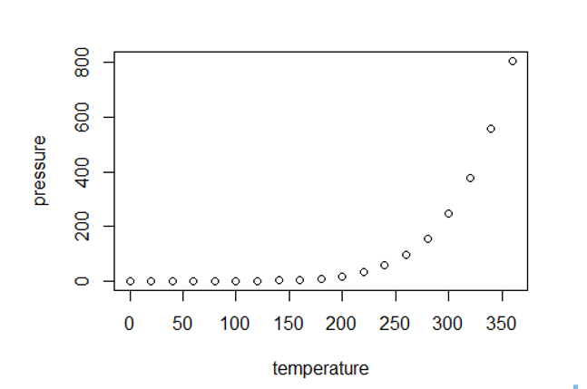

Note that the echo = FALSE parameter was added to the code chunk to prevent printing of the R code that generated the plot.